1. Introduction

Prerequisites
Authors may submit only papers that have not been published before and have been read and approved by all authors. The manuscript should not be submitted anywhere else while under consideration with SIC. If the manuscript has been accepted, the exclusive copyright is transferred automatically from the authors to the editors of Studies in Informatics and Control journal.

Typesetting and Structure
All manuscripts must be written in Microsoft Office Word 2016® and must comply with publisher’s instructions. The paper should be in English and should have the following structure:
The title should be as short as possible, with no abbreviations or acronyms.
- Author(s)
- Affiliation for each of the authors:
- Institution
- Address (Street, City, Zip, Country)
- E-mail
- Abstract
- Keywords
[All the above inside a borderless text box on the top of the first page]
- Content of paper
- Acknowledgements (if any)
- References and Annexes

Manuscript Template for
Studies in Informatics and Control journal
Author¹, Author² (Full Name: First name and FAMILY NAME)
¹ Institution, Street Address, City, Zip code, Country
e-mail
² Institution, Street Address, City, Zip code, Country
e-mail
Abstract: The title should reflect the contents of the manuscript. The abstract should be concise and descriptive; it shouldn’t exceed 200 words. The name(s) of the author(s) will be just below the title, in Bold characters, followed by their affiliation and the address of the institution they represent. Optionally they could send an e-mail address, as well.
Keywords: The author(s) should provide a short list of key words and phrases.

Paper size and format
All papers should be set between 8-10 pages (A4 format) including references. Footnotes should be avoided. The following margins should be set:
Left margin …………………... 2,7 cm
Right margin ………………..….. 2,7 cm
Top margin…………………….... 2,2 cm
Bottom margin ………………….. 2,0 cm
Header ………………………....... 1,4 cm
Footer …………………………… 1,6 cm
Multiple papers: Mirror
Different odd and even = checked

Main title: Times New Roman, 18, bold, centred, spacing after – single line of 12 pt.
Authors: Times New Roman, 10, bold, left aligned, spacing before and after – single line of 6 pt.
Affiliation: Times New Roman, 10, regular, left aligned, no spacing. For a single affiliation, no superscript is necessary. In case of different authors, from different institutions, one marks every name by a superscript number.
Abstract and Keyword: Times New Roman, 9, regular, justified. The Abstract is followed by the Keywords. The spacing for Abstract is 6 before and 3 after, single line; the spacing for Keywords is 3 before and 6 after, single line.
Chapters titles: Times New Roman, 14, bold, justified, spacing before and after – single line of 12 pt. The chapters are countered with Arabic figures.
The body of the article, acknowledgments and references should be edited on two columns, with 0.5 cm spacing between them, and no section breaks. The font for Body Text should be Times New Roman, 11 pts.
Original and high-standard scientific papers shall be drawn up in a concise style, avoiding any oversized introduction.
If you are asked to revise your submitted paper, please revise it seriously and recheck everything word by word. Perform visual inspections to detect subtle font errors and ensure that all fonts are embedded.

2. Other elements
Typesetting regarding:
- illustrations and graphs;
- mathematical formulae;
- numbered lists and sub lists;
- bulleted list;
- remarks
- in-text citations.
The above should meet the following specifications, as closely as possible. The final layout adjustments will be carried out by our editors.

Illustrations, Graphs and Tables
Illustrations and tables should be inserted in their appropriate place in the text, rather than attached at the end of the paper or as an appendix.
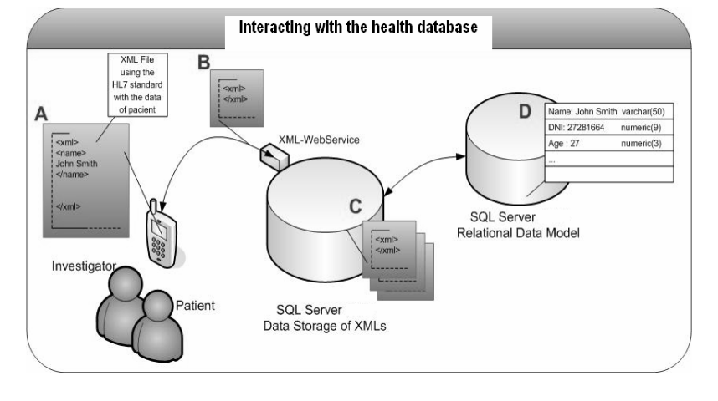
Figure 2. Example of wide figure (inserted in a borderless text box)

Figures are best prepared at the size you would expect them to appear in print. All images, both line drawings and photographs, must be supplied at a minimum of 300 dots per inch (dpi) at the maximum size they can be used, in .PNG format. Artificially increasing an image’s resolution in an artwork program will not improve its quality. Please, print and visually verify your own images before
submitting them. Cite all figures in the text consecutively and place them as close as possible to their first mention in the text.
Figures or tables that can fit within one column should be centered and must have a maximum width of 7.45 cm. Captions should be below the figures; table heads should appear above the tables. Insert figures and tables AFTER they are cited in the text, using the following style: Times New Roman, 10, regular, centered, spacing before and after – single line of 6 pt. The words “Figure/Table” should be written in bold. Captions should have continuous numbering. See Figures 1 and 2.

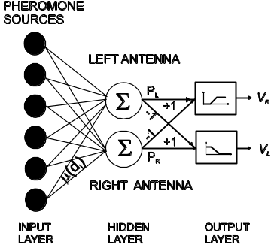
Figure 1. Description

Table 1. Typesetting specifications
Typeset | Font |  | Alignment | Paragraph spacing - pt |  | Remarks
Typeset | Size | Style | Alignment | Before | After | Remarks
Abstract | 9 | Regular | Justified | 6 | 3 | First word: bold
Affiliation | 10 | Regular | Left | 3 | 6 | Keep lines together
Author | 10 | Bold | Left | 6 | 6
Body Text | 11 | Regular | Justified | 6 | 6
Bulleted list | 11 | Regular | Justified | 0 | 3 | Tab = 0.63
Chapters | 14 | Bold | Justified | 12 | 12 | Hanging = 0.63
Figure / table explanation | 10 | Regular | Centered | 6 | 6 | First word: bold
Key words | 9 | Regular | Justified | 3 | 6 | First word: bold
Numbered list | 11 | Regular | Justified | 6 | 6 | Tab = 0.63  Numbered
References | 11 | Regular | Justified | 6 | 6 | Numbered, in strict alphabetical order  See above
Section | 12 | Bold | Justified | 6 | 6 | Hanging = 0.63
Title | 18 | Bold | Centered | 0 | 12

Larger illustrations or tables may span across both columns. They will be inserted in a borderless text box. The width of these illustrations / tables must not exceed 15 cm.
Authors should provide the written permission from the copyright owners for any illustration/ graph/ figure excerpted from copyrighted sources that are included in their paper.

Mathematics – Formulae
Mathematical formulae should be arranged so they fit within one column. They should be left aligned and should have an identification number on the right margin, enclosed in parentheses. The numbering should be continuous:
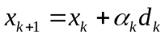, (1)
or
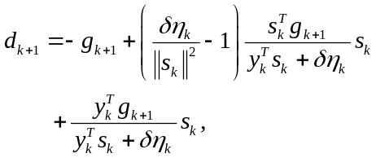 (2)
For formulas and equations within the article use only MathType – minimum version 6.9.

Lists
For typesetting lists, numbered of bulleted please import the styles from the examples above, on the first page of this presentation.
Remarks
Remarks, definitions and examples should be in regular font rather than in italic.
In-text citations
• Citing one author
When citing the work of an author, mention the name of the author, followed by the publication year of the respective work (e.g. Groumpos, 2018).
You can also write: “Groumpos (2018) proposed a new modelling and control theory for addressing the complex dynamic systems (CDS)”.
• Citing works by the same author written in the same year
If you cite another work of the same author which was written in the same year as a previous citation, you should use a lowercase letter after the year of publication in order to differentiate between the works. (e.g. Zavadskas, 2015a; Zavadskas, 2015b).
• Citing two or three authors
If the respective work has two or three authors, you should include all names in your citation.
Young students proved to be mostly motivated to use Minecraft in its creative mode that enhanced learners’ problem-solving skills and helped them to reach a compromise (Thorsteinsson & Niculescu, 2008).
In 2008 a hybrid approach that combines ant system optimisation and fuzzy logic concept to facilitate the multi-objective HPSP optimisation, such as the makespan, and the processors workload was introduced (Liouane, Yahia & Borne, 2008).
• Citing four or more authors
If the cited work has four or more authors/editors you should use the abbreviation “et al.” after the first author’s name. It is also acceptable to use the formula “et al.” after the first author in case that the work has three authors.
Certain studies investigated the main consensus methods proposed in social networks and brought out the new challenges that should be faced in this research field. (Herrera-Viedma et al., 2017).
• Citing non-print or sources from the Internet (from works that have no obvious author)
If you cite a piece of work with no obvious author, you should use a so-called ‘corporate’ author. For example, many online publications have no individually named authors, and in many cases the respective author will be an organisation or company.
The second is the Gaussian Distribution, which is used when the amount of data used to calculate the mean and standard deviation is above 32 values, as described in the Statistical Handbook (NIST/SEMATECH, 2012).
If you won`t find either an individually named or corporate author, you should use ‘Anon’ as the author name.
Authors may also read “Citing & Referencing: Harvard Style”.

Acknowledgements
Authors who wish to acknowledge certain facts use an unnumbered section after the Conclusions chapter just before References.
References
The title, REFERENCES, will be written as chapter title. Entries should be listed in strict alphabetical sequence by the first listed author's last name. For the works with more than three authors, please only include the names of the first three authors, followed by the mention “et al.”. See the following examples:
- citing a journal article
Zavadskas, E. K., Bausys, R., Lesciauskiene, I. et al. (2020) M-generalised q-neutrosophic MULTIMOORA for Decision Making. Studies in Informatics and Control. 29(4), 389-398. doi: 10.24846/v31i4y202201.
- citing a preprint journal article
Oliu, M., Selva, J. & Escalera, S. (2017) Folded Recurrent Neural Networks for Future Video Prediction. To be published in European Conference on Computer Vision. [Preprint] https://arxiv.org/abs/1712.00311 [Accessed 15th June 2017].
- citing a book
Weidmann, C. & Teuber, L. (2009) Conception and Installation of System Monitoring Using the SAP Solution Manager. New York, Galileo Press.
- citing a conference proceeding
Lorenz, G. V. & Buhtz, K. (2017) Social influence in technology adoption research: a literature review and research agenda. In: Ramos, I., Tuunainen, V. and Helmut Krcmar, H. (eds.) Proceedings of the 25th European Conference on Information Systems, ECIS 2017, 5-10 June 2017, Guimarães, Portugal. Atlanta, Georgia, Association for Information Systems. pp. 2331-2351.
- citing a thesis/dissertation
Leclercq, L. (2004) Apport du stockage inertiel associé à des éoliennes dans un réseau électrique en vue d’assurer des services systems. PhD thesis, Lille University.
- citing a webpage
Hammersley, H. (2017) Concerned about Brexit? Why not become an e-resident of Estonia. https://www.wired.co.uk/article/estonia-e-resident [Accessed 15th June 2017].
United Nations Organization (ONU). (2018) 2018 Revision of World Urbanization Prospects. https://www.un.org/development/desa/en/news/population/2018-revision-ofworldurbanization-prospects.html [Accessed 4th May 2018].
- citing a report/discussion paper
Financial Conduct Authority. (2017) Discussion Paper on Distributed Ledger Technology. Discussion Paper: DP17/3. https://www.fca.org.uk/publication/discussion/dp17-03.pdf [Accessed 15th June 2018].

Entries should be written in 10 point Times New Roman font, single spaced.

